**FIGURES**

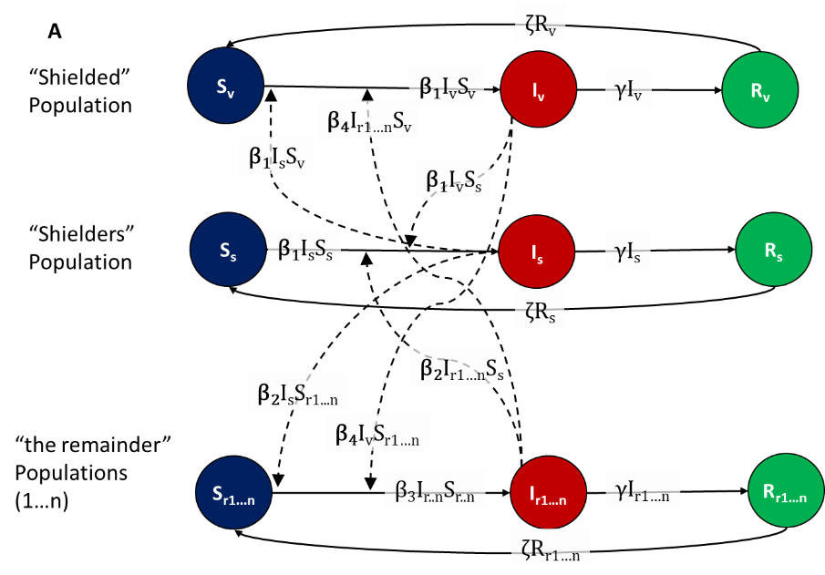

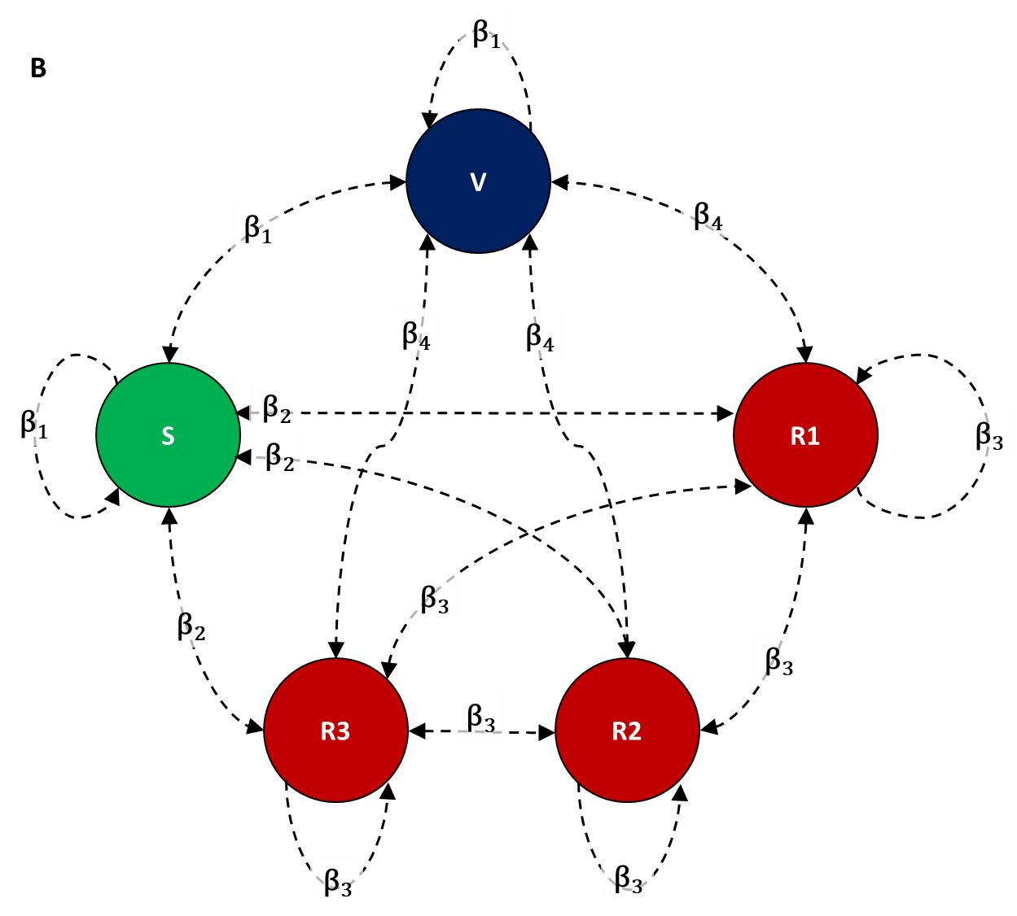

**Figure 1 - The SIRS model structure** (A) defined by Susceptible, Infectious and Remainder compartments and (B) the 20-20-20-20-20 network structure with five equal sized populations: vulnerable (V), shielders (S) and three remainder populations (R1, R2 and R3). This illustrates the baseline with five equal sized populations, but can be extended to n equal sized populations by increasing the number of remainder subpopulations. We define four values of the rate of transmission (β) with β1 defining the rate of transmission within and between the vulnerable and shielders; β2 defines transmission between shielders and remainders; β3 defines transmission between the remainder populations and β4 defines transmission between remainder and vulnerable populations.

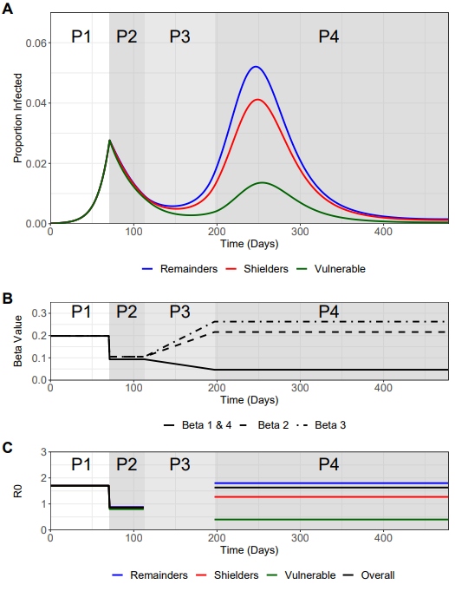

**Figure 2 – Trajectory plots for the vulnerable, shielders and remainder populations, with accompanying β and R0 plots**.

A) Trajectory plots of the proportion of infecteds in the vulnerable (green), shielders (red) and remainders subpopulations (blue), shading depicts the different phases of enhanced shielding intervention.

B) Values for the different β over the course of the simulation as they are implemented for the different intervention phases.

C) Values of the corresponding R0’s (colors) for the different subpopulations and the overall R0 (black) during the different intervention phases.

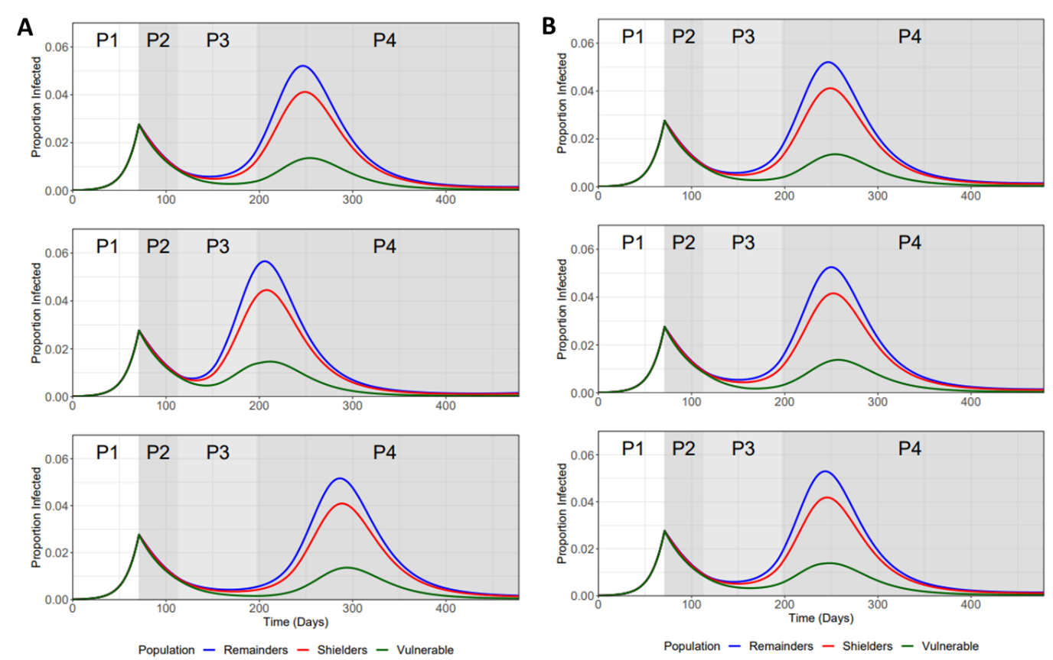

**Figure 3 – Sensitivity analysis for the length of phase 3 ramp-down (β1 & β4) and ramp-up (β2 & β3) periods.** Top plot for both A) and B) refers to baseline values.

A) TOP plot: 12 Weeks ramp-up (β3 & β4) and 12 Weeks ramp-down (β1 & β4), MIDDLE plot: 6 Weeks ramp-up and 12 Weeks ramp-down, BOTTOM plot: 18 Weeks ramp-up and 12 Weeks ramp-down.

B) TOP plot: 12 Weeks ramp-up (β3 & β4) and 12 Weeks ramp-down (β1 & β4), MIDDLE plot: 12 Weeks ramp-up and 6 Weeks ramp-down, BOTTOM plot: 12 Weeks ramp-up and 18 Weeks ramp-down.

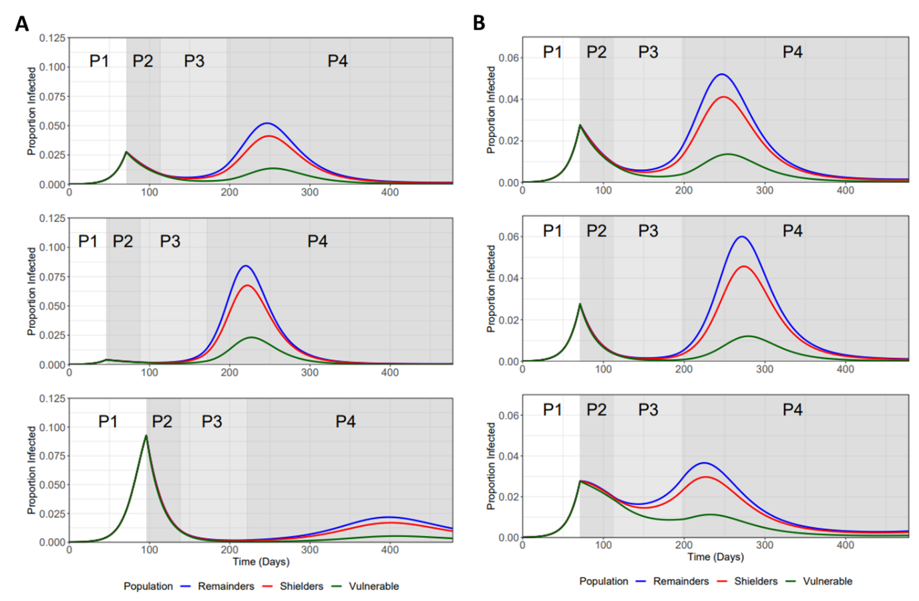

**Figure 4 - Sensitivity Analysis for varying the trigger Point and phase 2 β.** Top plot for both A) and B) refers to baseline values.

A) Trajectory plots for the different subpopulations for different trigger points (starting day of lock down; I(t) refers to the fraction of vulnerable infected on trigger day): TOP plot: day 71 (I(t) = 0.0277), MIDDLE plot: day 46 (I(t) = 0.0042), and BOTTOM plot: day 96 (I(t) = 0.0.093).

B) Trajectory plots for the different subpopulations for variation in phase two betas – variation is referred in terms of the R0 values used to calculate β1 & β4 (first number) and β2 & β3 (second number): TOP Plot: 0.8/0.9 (Baseline), MIDDLE Plot: 0.6/0.7, and BOTTOM Plot: 1.0/1.1.

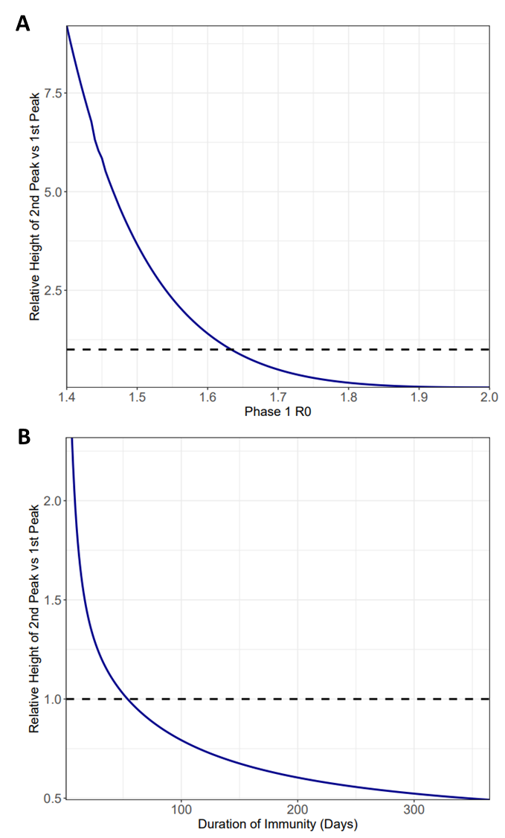

**Figure 5 – Relationship between Phase 1 Beta and Zeta values (expressed in 1/zeta) on the relative height of 2nd peak vs 1st peak for the vulnerable population.** Dotted line represents the point at which the first IV peak equals the second IV peak.

**A)** Phase1 R0 is varied between 1.4 – 2.0 (with baseline being 1.7). R0 values are used to calculate the β in each model run.

B) The duration of immunity (1/ζ) is varied between 0 and 365 days (baseline).

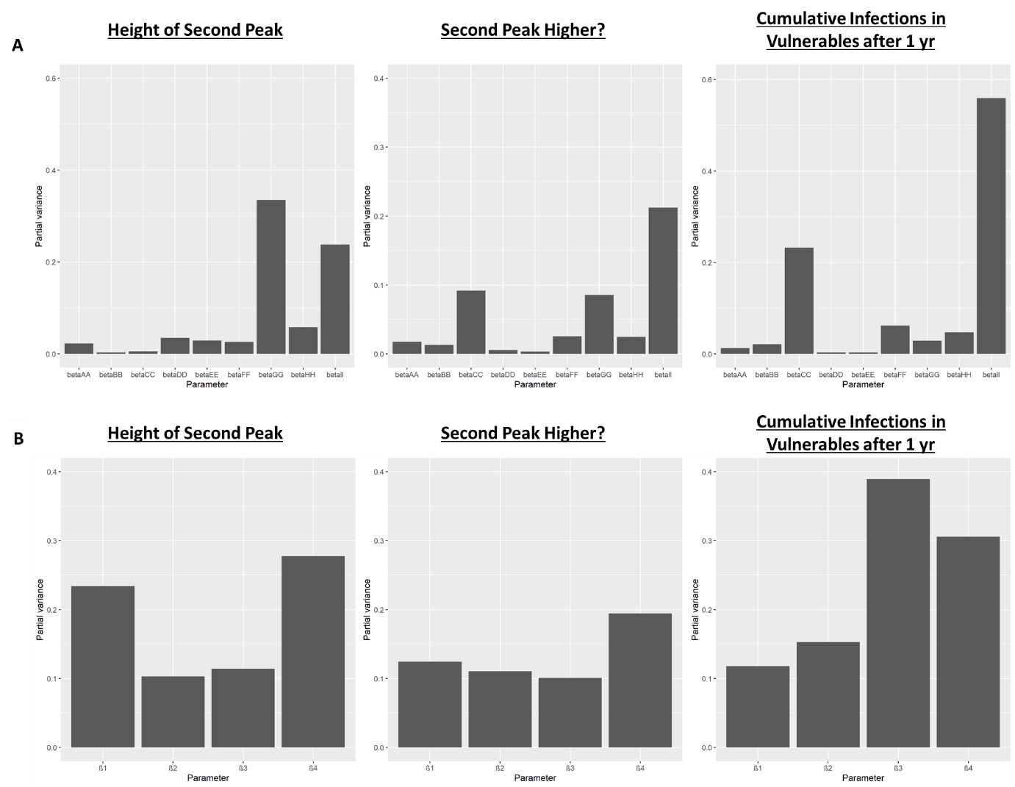

**Figure 6 – Results of a global sensitivity analysis on three key epidemic measures with regards the proportion of the vulnerable population that become infected (Iv): 1) the height of the second peak of Iv; 2) whether the second peak of Iv is higher than the first peak and 3) cumulative Iv one year after the start of the lockdown.** A) The bars show the partial variance of the individual model parameters. Higher bars indicate greater sensitivity of the model to that parameter. The results clearly show that it is beta_II and β3 (parameters that determine transmission between the non-vulnerable populations) that will be key to determining the size of epidemic that affect the vulnerable population. See Material and methods section for details about the sensitivity analysis and parameter ranges used.

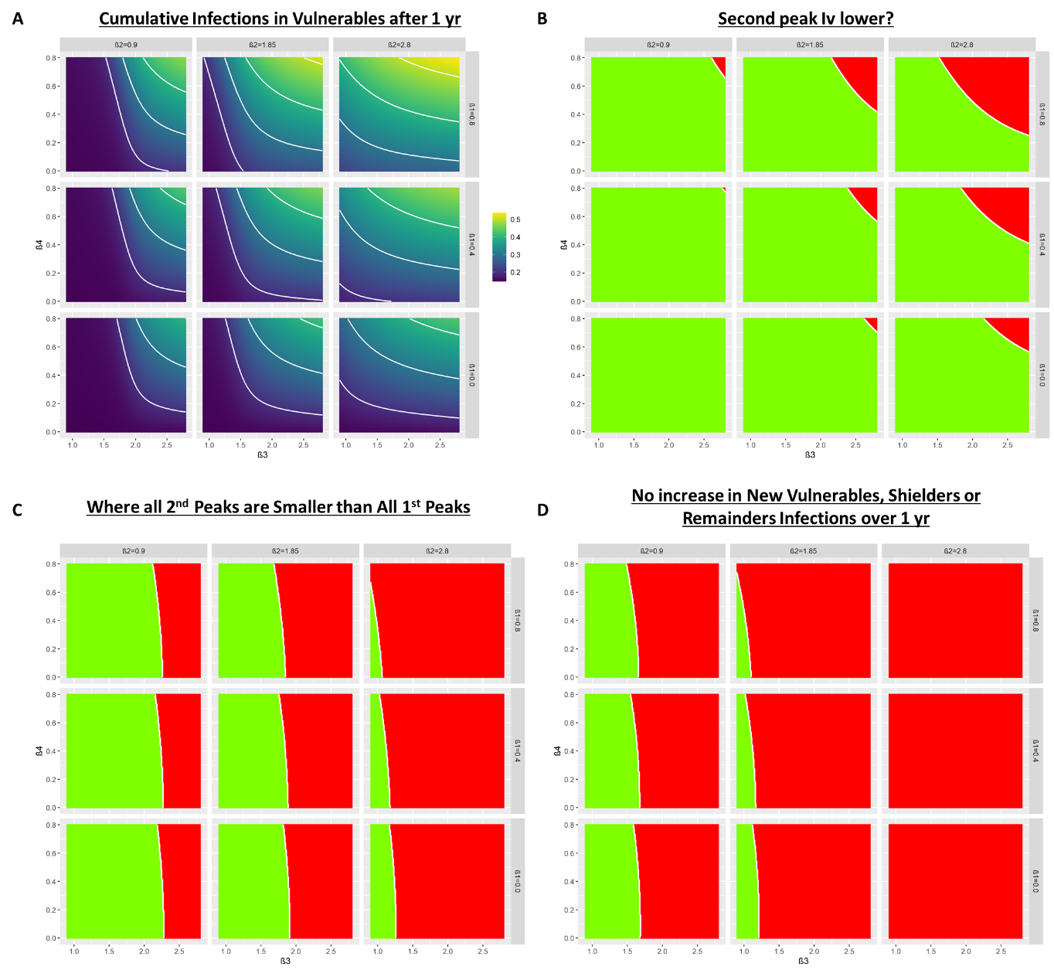

**Figure 7 – Heat maps showing the trade-offs between relaxation and protection.**

A) Each subplot depicts a heat map showing the cumulative fraction of the vulnerable population that become infected (Iv) one year after the start of lockdown for different combinations of β3 & β4 for different values of β1 (rows) and β2 (columns).

B) As A) but for whether the second peak of is lower (green) or higher (red) than the first peak.

C) As (B) but all 2nd peaks (Iv,Ih & Ir) smaller than 1st peaks (green).

D) As (B) but dI­/dt negative or zero for at least 365 days after the start of lockdown for all I-compartments.